**LAB # 10**

**Services – Started Services**

**TASK-1:**

You have to create an Android application by which a started-service can be started or stopped by the user through start-button and stop-button respectively. There must be a provision in the UI to include stopSelf() method for execution if user want it.

Suppose all the service lifecycle callback methods are displaying their names in **Logcat** screen. These methods include only the follows:

* onCreate()
* onStartCommand()
* onDestroy()

You may have the following UI for this task:

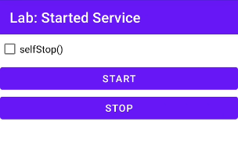

**TASK-2:**

Observe the behavior of your app, developed in Task-1, and fill out the table below:

User is assumed to restart the app every time before any of the following options is answered:

|  |  |  |  |
| --- | --- | --- | --- |
|  | | **stopSelf() execution option during service call** | |
| **stopSelf() is enabled** | **stopSelf() is disabled** |
| **Button pressing sequence** | **start** |  |  |
|
|
| **start, stop** |  |  |
|
|
| **start, stop, start** |  |  |
|
|